Standard text – fundraising.

About Us
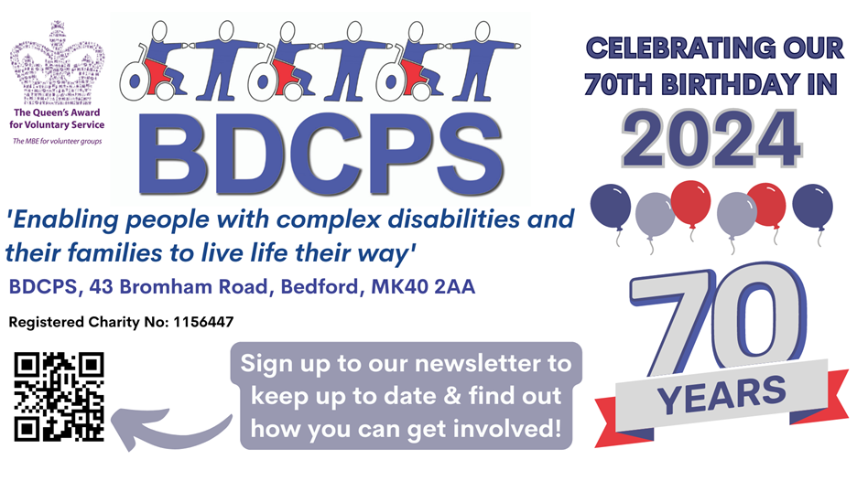

BDCPS is a small charity based in Bedfordshire, which for nearly 70 years has supported people with complex disabilities and their families. We were honoured to receive The Queen’s Award for Voluntary Service in 2018.
At BDCPS we focus on ABILITY rather than disability. We are passionate about providing a ‘greenhouse’ where young people are able to grow, aspire, dream and achieve greater things. We aspire beyond just meeting the basic needs and provide extraordinary activities and adventures for extraordinary young people. Our families trust that we will provide safe activities that will enable their young person to bloom.
We also extend the greenhouse to include the whole family and provide much needed support for parent carers and siblings, including wellbeing activities, emotional and practical support and sibling adventures.
We grow organically based on the needs of our beneficiaries. We are passionate about coproducing with our families and young people and find creative ways for everyone to have their voice.
And we listen!
We pride ourselves on our ability to adapt to changing environments and have a responsive and flexible approach to all that we do. For nearly 70 years we have been enabling people with complex disabilities and their families to live life their way.

Dress 2 Express

Be You-nique, Be You-tiful, Be you!
Sign up your school, college, company or just you and your friends. On the last day of school before Easter holidays we hold our annual dress-up/down day. Pay £2 and come as your You-nique, Be You-tiful self and Be-You on Dress2Express day 2024. If you want you can add a little bit of sparkle to celebrate our Platinum birthday! Join us in celebrating our 70th Birthday next year and sign up to Dress2Impress day 2024.

Flyer below

Cream Tea month
Every June, we ask you to host your own cream tea event, whereby you bake (or buy!) a few cakes and scones, brew some tea and invite a few friends and family over for a small donation to BDCPS! It really is that simple!

Flyer below

Activities
We provide extraordinary activities for extraordinary young people through our specialist activity clubs and schemes. Stampede is our monthly youth club for young people aged 5 to 12. Then we have JJ's Crew, a teenage youth club for young people aged 13-17. And not forgetting ACE Unlimited - Achieving, Creating, Empowering, a pioneering monthly youth club for those aged 18+.
Skools Out is our school holiday activity scheme running in Summer, Easter and half term holidays.

Family Support Service
Our family support service is an example of a service that has grown in response to the needs of our families. BDCPS understand how isolating it can be entering into the unknown world of having a child with a disability and wanted to reach families as early as possible.
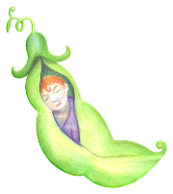
Little Sweet Peas is our weekly group for pre-schoolchildren and their parent carers to enjoy music, stories and sensory play in an informal and relaxed environment. Trained staff and volunteers are on hand [for cuddles] to give parent carers a chance to chat to our Family Support Workers or just to have a cuppa and some lunch with other parent carers.
Our small team of Family Support Workers are trained staff, many who are parent carers themselves. They can provide support, guidance, signposting and many practical tasks, from helping to complete disability benefit forms to supporting at meetings or just being a friendly ear in times of crisis.

Wellbeing
It started as a monthly breakfast where parent carers could enjoy a meal and a chat and has now grown into a Wellbeing Service. We provide wellbeing sessions known to be beneficial for your mental health such as Nidra Yoga, art and craft sessions, massage, Sound Baths, walking groups and many more. We also hosted a Menopause Matters session this year with a menopause specialist. Any parent carer of a child with SEND can join our sessions regardless of whether their children come to our clubs. Come along to have some well-deserved ‘me-time’ and enjoy a drink and a chat afterwards, with our Family Support Workers on hand if needed.

Easyfundraising
We’re now registered with easyfundraising, which means you can help us for FREE. Over 7,000 brands will donate to us when you use easyfundraising to shop with them – at no extra cost to yourself! All you need to do is sign up and remember to use easyfundraising whenever you shop online. It’s easy and completely FREE! These donations really mount up, so please sign up to support us at https://www.easyfundraising.org.uk/causes/bdcps/?utm_campaign=raise-more&utm_medium=email&utm_content=rm-en-n1

Flyer below

Posters and Flyers

